**ST. XAVIER’S COLLEGE**

**(Affiliated to Tribhuvan University)**

**Maitighar, Kathmandu**



**COMPUTER GRAPHICS**

**LAB ASSIGNMENT#5**

**Submitted by:**

Shreesha Pokharel

013BSCCSIT038

**Submitted to:**

|  |  |
| --- | --- |
| **Er. Anil K. Sah** |  |

Lecturer

Department of Computer Science

Date of submission: 21st August, 2015

**Statement: Implement midpoint circle algorithm.**

**Algorithm:**

Step 1: input radius r and circle centre (xc, yc), and obtain the first point on circle centered at origin as

(x0, y0) = (0, r).

Step 2: calculate initial decision parameter

Po=

Step 3: at each xk position, starting at k=0, perform the tests:

If Pk<0 next point along the center at (0, 0) is (xk+1, yk)

Pk+1= Pk+2 xk+1+1

Otherwise, the next point along the circle is (xk+1, yk-1)

Pk+1= Pk+2 xk+1+1-2 yk+1

Where 2 xk+1=2 xk+2 and 2 yk+1=2 yk+2

Step 4: determine symmetry point on the other seven octants.

Step 5: move each calculated positions (x,y) in to circle path centered at (xc, yc) as

x=x+xc and y=y+yc

Step 6: repeat 3 through 5 until x≥y.

Step 7: terminate.

**Source code:**

//---------------------------------------------------------------------------

#include <vcl\vcl.h>

#pragma hdrstop

#include "Unit1.h"

//---------------------------------------------------------------------------

#pragma resource "*.dfm"

TForm1 *Form1;

int xc,yc,r,pk,x,y;

//---------------------------------------------------------------------------

__fastcall TForm1::TForm1(TComponent* Owner)

: TForm(Owner)

{

}

//---------------------------------------------------------------------------

void __fastcall TForm1::Button1Click(TObject *Sender)

{

r=StrToInt(Edit1->Text);

xc=StrToInt(Edit2->Text);

yc=StrToInt(Edit3->Text);

x=0;

y=r;

pk=1-r;

Image1->Canvas->Pixels[x][y]=RGB(100,200,200);

while(x<y)

{

if(pk<0)

{

pk=pk+2*(x+1)+1;

x++;

Image1->Canvas->Pixels[xc+x][yc+y]=RGB(100,200,200);

Image1->Canvas->Pixels[xc-x][yc+y]=RGB(10,200,100);

Image1->Canvas->Pixels[xc+x][yc-y]=RGB(150,210,250);

Image1->Canvas->Pixels[xc-x][yc-y]=RGB(255,0,0);

Image1->Canvas->Pixels[xc+y][yc+x]=RGB(0,255,0);

Image1->Canvas->Pixels[xc-y][yc+x]=RGB(0,0,255);

Image1->Canvas->Pixels[xc+y][yc-x]=RGB(55,56,211);

Image1->Canvas->Pixels[xc-y][yc-x]=RGB(58,250,158);

}

else

{

pk=pk+2*(x+1)+1-2*(y+1);

x++;

y--;

Image1->Canvas->Pixels[xc+x][yc+y]=RGB(100,200,200);

Image1->Canvas->Pixels[xc-x][yc+y]=RGB(10,200,100);

Image1->Canvas->Pixels[xc+x][yc-y]=RGB(150,210,250);

Image1->Canvas->Pixels[xc-x][yc-y]=RGB(255,0,0);

Image1->Canvas->Pixels[xc+y][yc+x]=RGB(0,255,0);

Image1->Canvas->Pixels[xc-y][yc+x]=RGB(0,0,255);

Image1->Canvas->Pixels[xc+y][yc-x]=RGB(55,56,211);

Image1->Canvas->Pixels[xc-y][yc-x]=RGB(58,250,158);

}

}

}

//---------------------------------------------------------------------------

**Input:**

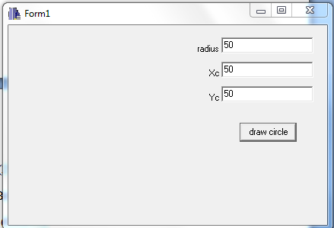

**Output:**

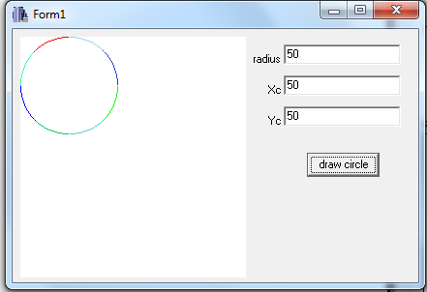

**Conclusion:**

Hence, midpoint circle algorithm was implemented.

**References:**

[1] D. Hearn and M. Baker, Computer Graphics, second edition.